# How to use the website

## Ticket booking

1. Trip details
2. On the main page fill in all fields of the form, except the second date field if you are planning to buy a one-way ticket.
3. Choose preferred vehicles, selecting none is equal to selecting each.
4. Adjust the number of passengers by clicking the minus and plus icons.

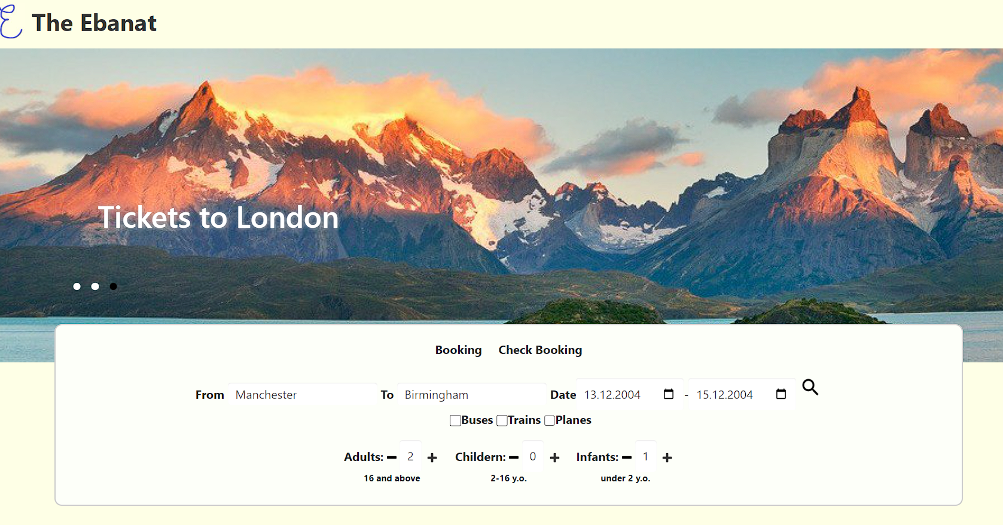

1. Press “Enter” key on your keyboard or clicking on magnifying glass icon when you are ready to continue.
2. Choosing the right trip
3. Select desired trip and return (if chosen previously) route by clicking on it. The total price will dynamically display next to the Continue button.

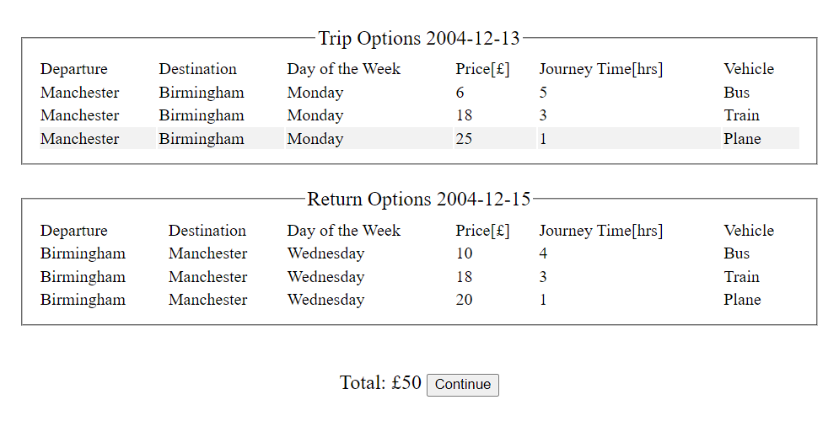

1. Whenever you are ready to continue click on the Continue button.
2. Entering personal details and purchasing
3. Enter every field of the form for each passenger in the Passenger section.
4. Enter card details to Card Details section.

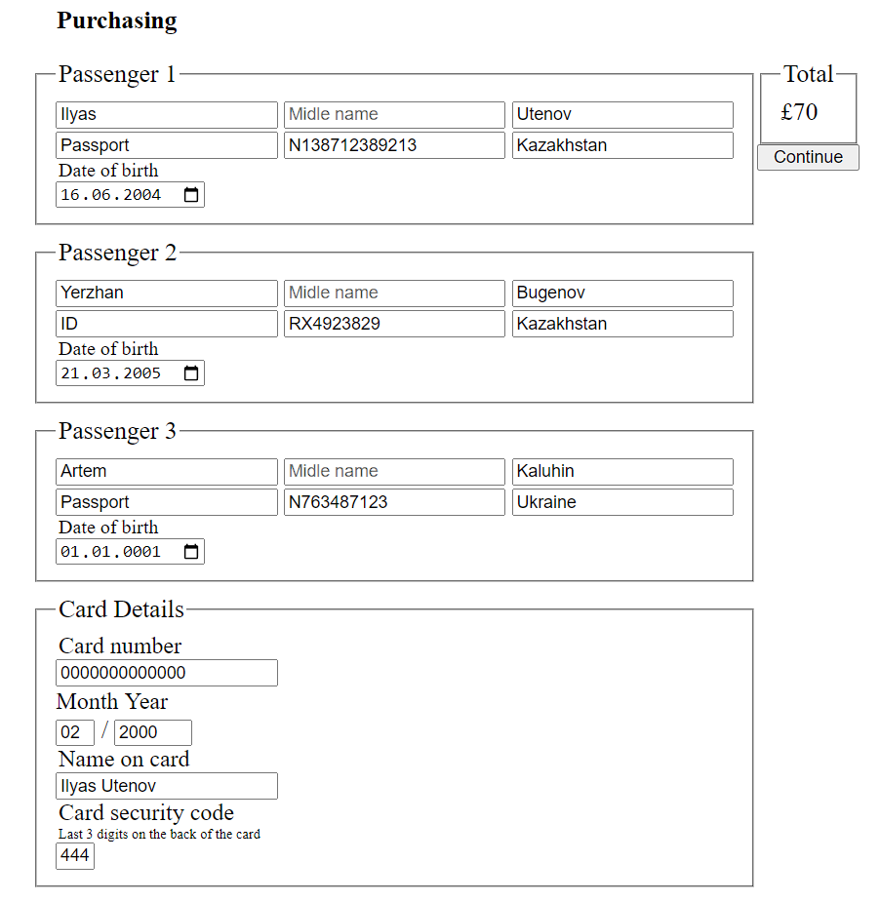

1. Once you are sure that all entered data is correct and you are ready to continue, click on Continue button. Next page is the last one.
2. Getting the tickets
3. Once the page is loaded you will see tickets for every passenger, each has details about the trip and contains unique Reference Number. Better save these numbers somewhere as they will be required for boarding as well as checking the booking.

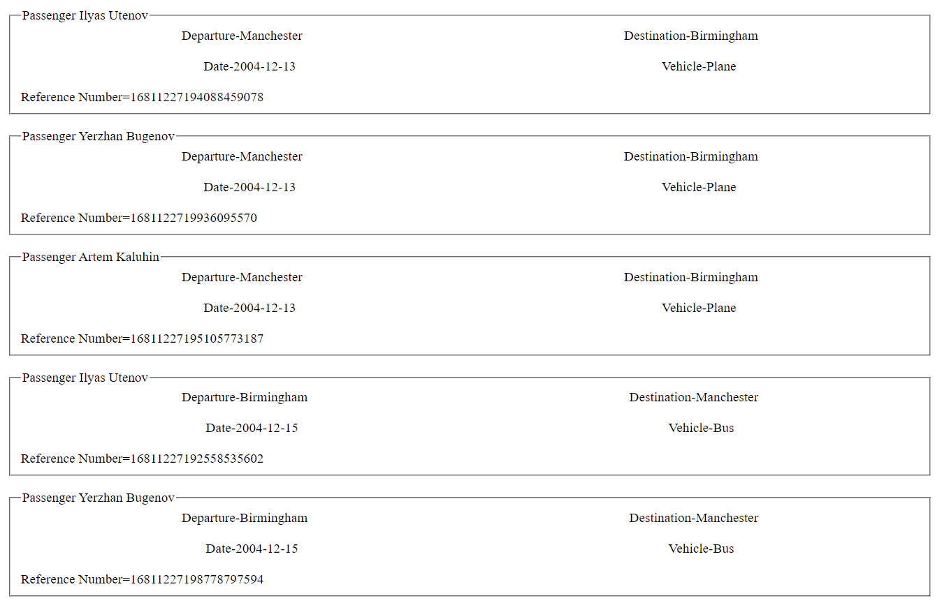

## Check booking

1. Accessing check booking form
2. To access the check booking form, click on the Check Booking label at the top-center of the Booking form box.

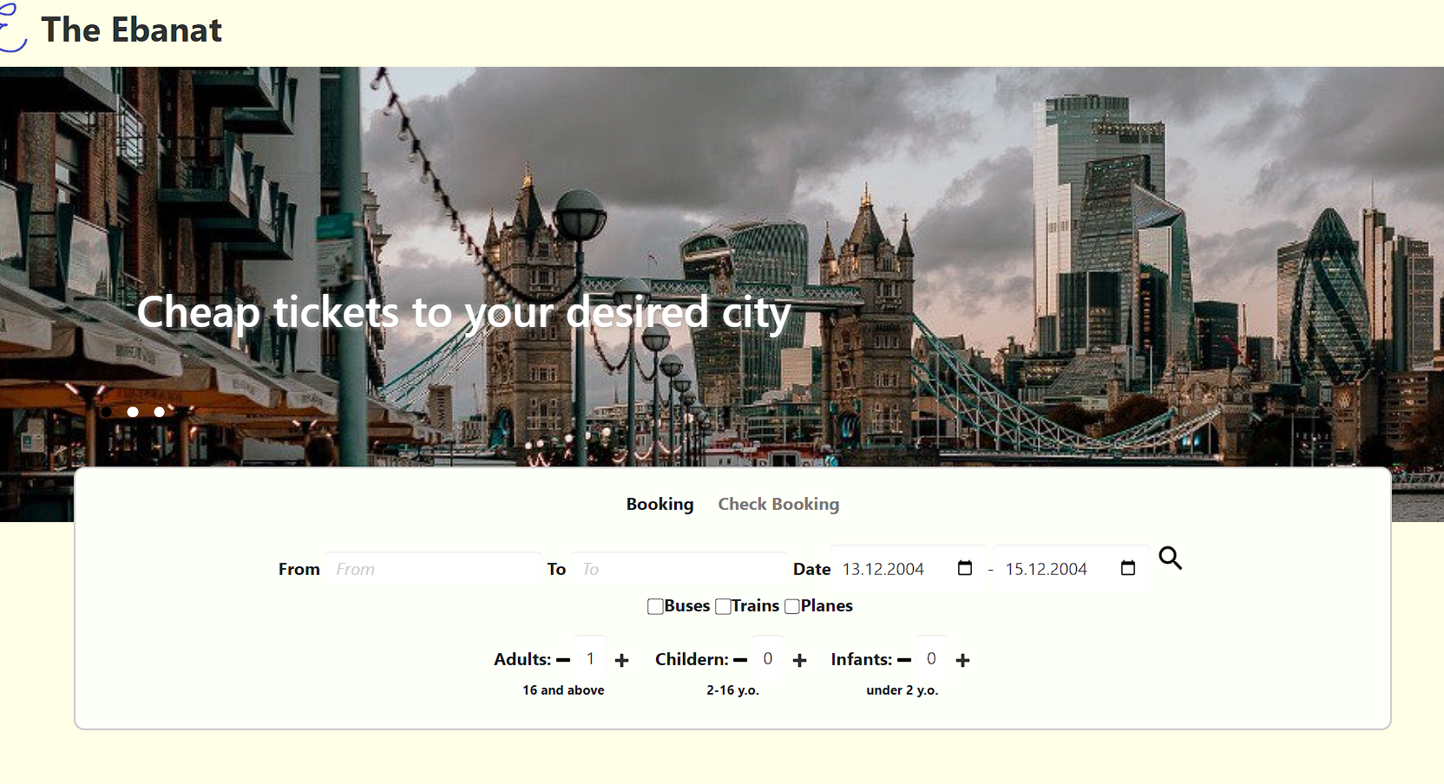

1. That’s how page will look after you click it:

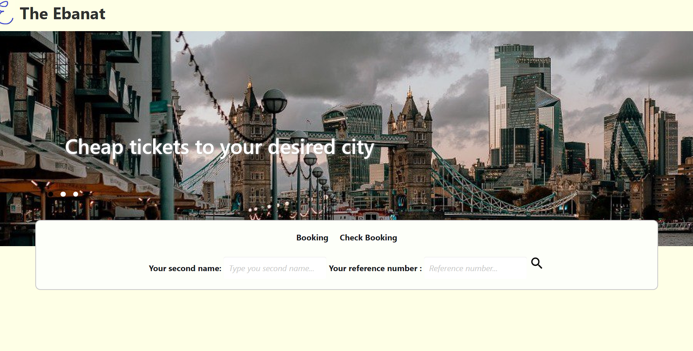

1. Completing the Check Booking form
2. In the corresponsive fields enter the reference number and second name of the person it was booked for.

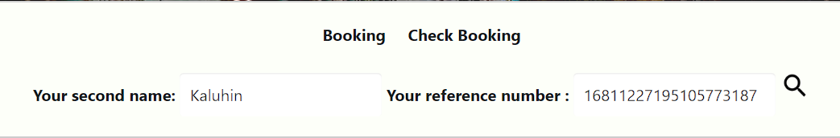

1. Whenever you are sure, entered data is correct and ready to continue, click on the magnifying glass icon.
2. Reviewing the ticket
3. If entered data is correct, you will see the right ticket as it would appear at the final page of booking process.

